Manyavar Deployment Process:

1. Take a Image Backup of Cookie Cutter (11.0.3.20 ) & provide a meaningful name with date.

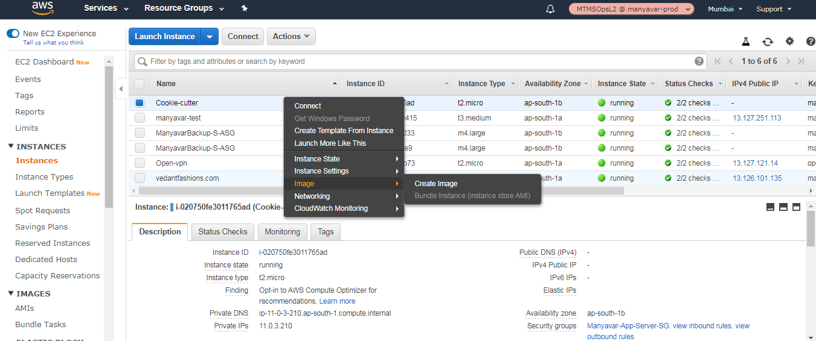

1. After the AMI is available, create a launch configuration
2. Goto Autoscaling Group >> Launch Configuration>>Create Configuration.

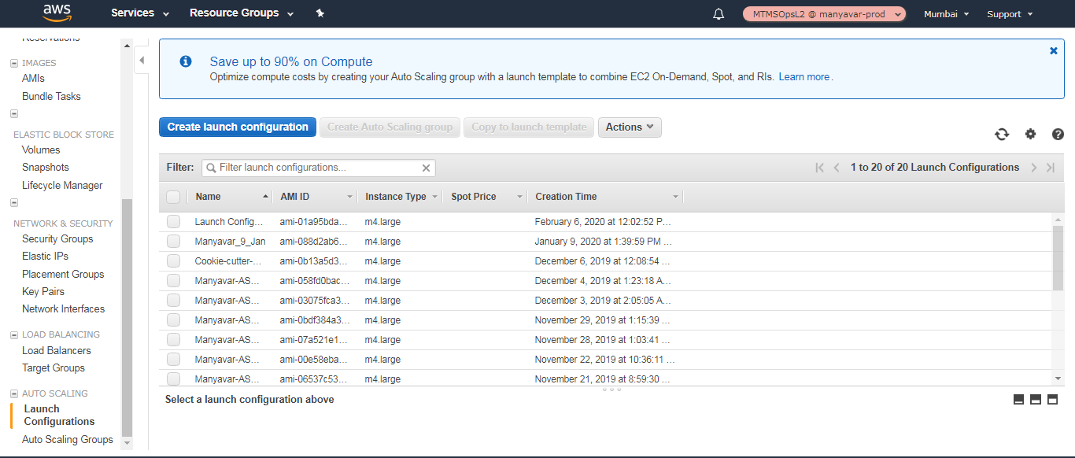

1. Choose the AMI, Instance type.

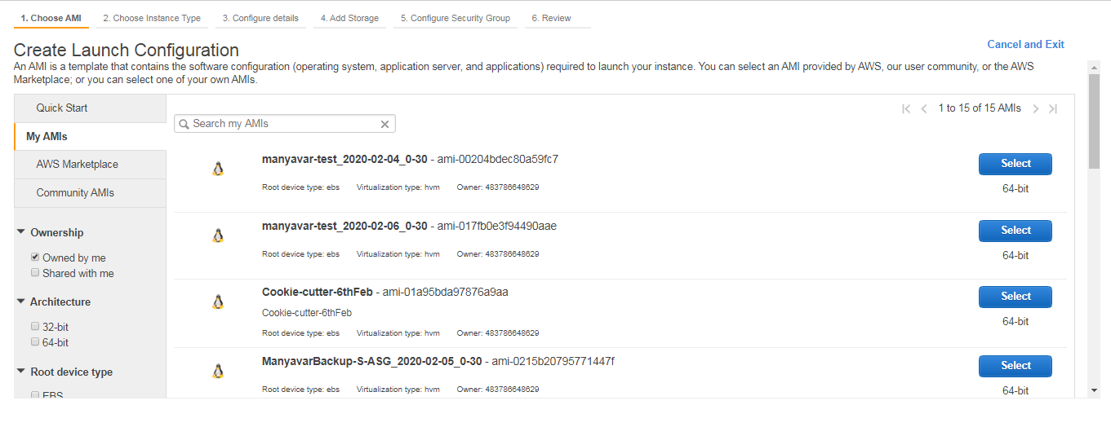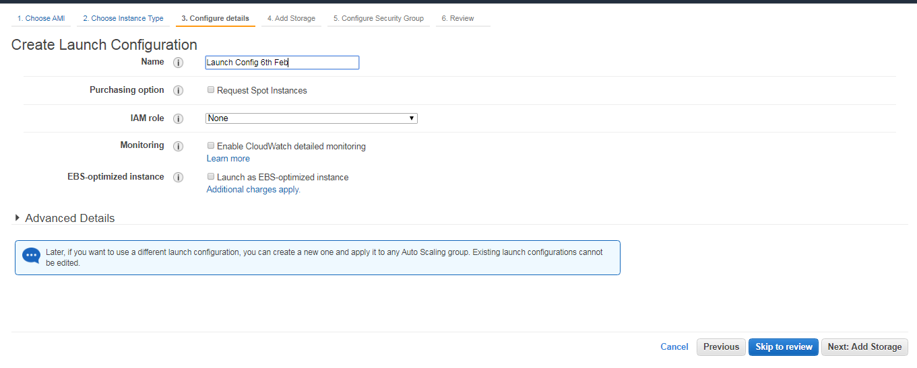

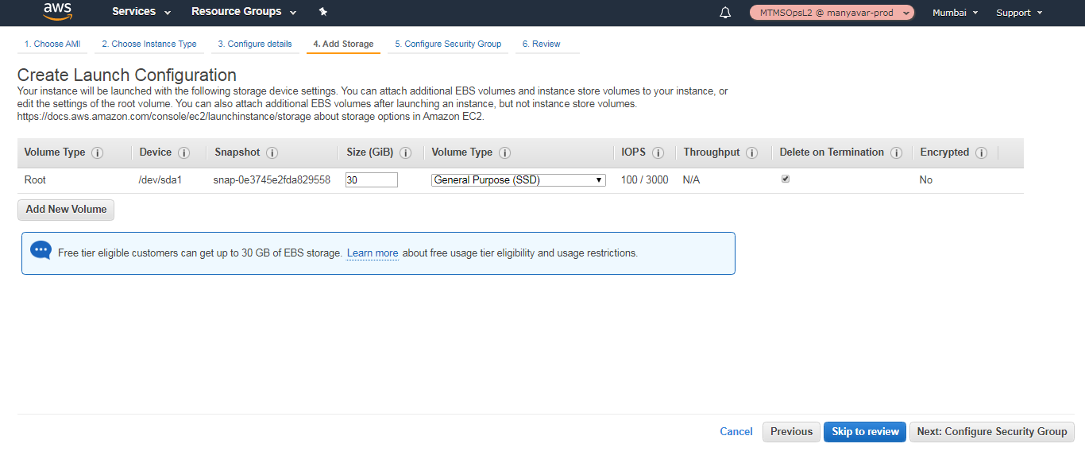

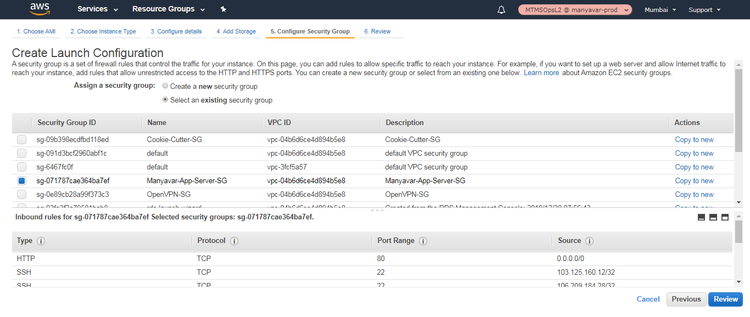

1. Review and Create Launch Configuration

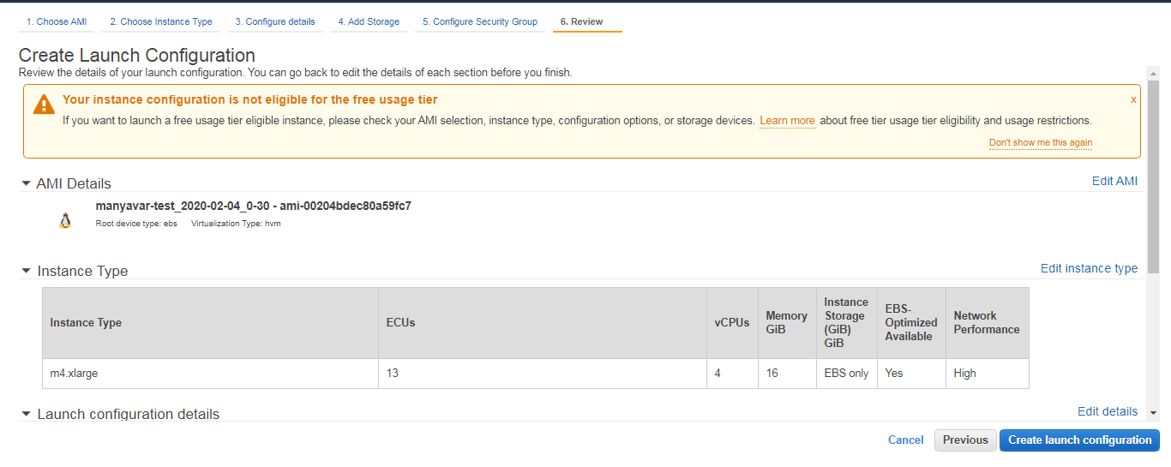

3 Goto Auto Scaling Group. Set the Launch Configuration; Edit the Desired Capacity to 4; Min to 4.

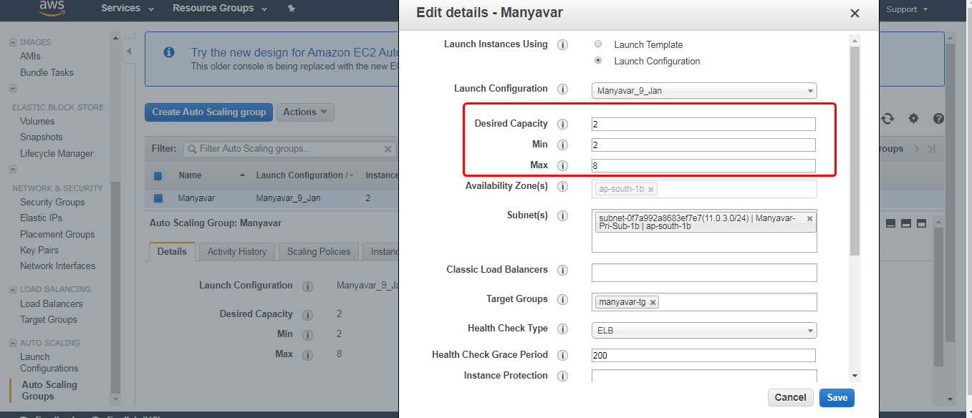

1. Goto Scaling Policies Tab, You’ll find 2 new servers launched. Wait till 2 new servers are healthy state.
2. Remove Scaling Policy for previous two ASG servers and set the Scale in for two new servers.
3. Edit back the Autoscaling Group, Desired Capacity to 2 and Min to 2. Save the changes.

You should see the new code deployed in the new ASG servers.